Risk Profiler

Data By:

Area Scenario Training Download About Contact

Without Retrofit

With Retrofit

View By Map View by Rank

**Summary: QUEBEC**

Deaths Damage Dollars

# 40,000

Search

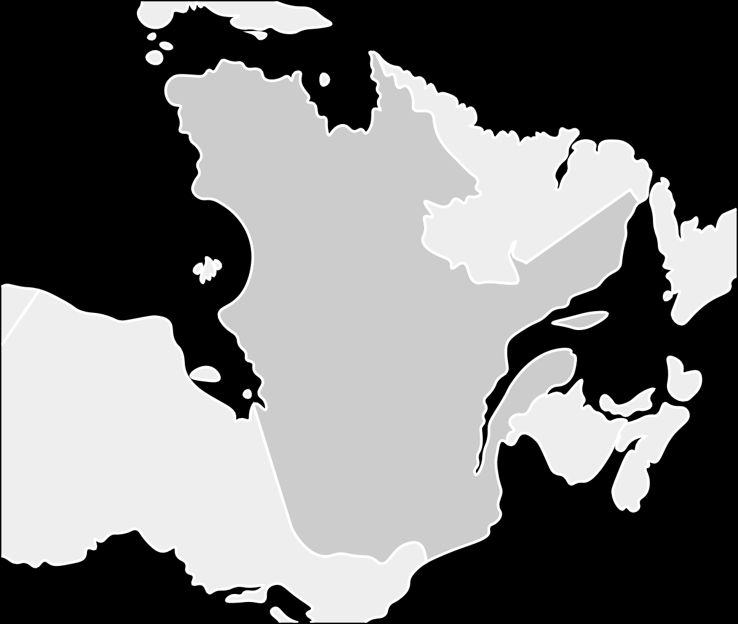

Municipality Name

**Deaths: 12,000**

**Damage: 54 buildings Dollars: $12,000,000**

**-**

**+**

Click to View Details

Back to National View

Search

of 1,200,000

people

43

of 1000 buildings

# $43 Million

of $1.6 Billion





Footer

Select Boundary:

Select indicator:

New? Take The Tour

Fatalities

Municipal

Occupancy of The Buliding ?

Expand

Code Level of the Building ?

Expand

Construction Material ?

Expand